UCab – Website User Flows

Full-Stack Taxi Booking Application
Date: June 26, 2026

────────────────────────────────────────────────────────

Overview
This document captures the end-to-end user flows for the UCab web application. It focuses on what the user does on the website (UI steps) and how the system responds at a high level, including real-time events with Socket.IO. Use this as a reference for design reviews, QA scenarios, and onboarding.

Actors & Assumptions
Actors: Rider, Driver (Admin features are future work).
Assumptions: Web UI built with React + Leaflet; backend Node/Express + MongoDB; JWT auth; Socket.IO for real-time ride requests and acceptance.

Global Pre- Conditions
  - User has a stable internet connection and a modern browser.
  - User account exists (or can self-register).
  - Location permissions enabled for accurate pickup suggestions (optional).

Rider Flow (Website)

Register / Login
  - Enter name, email/phone, password; role=rider.
  - On success, JWT stored in memory/local storage (per app policy).

Set Pickup & Drop on Map
  - Use map to select coordinates; auto-calculate distance and estimated fare.
  - Validate field names: prefer pickupLocation / dropLocation; estimatedFare ↔ fare alignment.

Request Ride
  - Create booking (status=pending). Rider joins rider-specific Socket room.
  - Fallback UI if no drivers respond within SLA (e.g., 30–60s).

Wait for Acceptance (Real- time)
  - Drivers in the matching vehicleType room receive newRideRequest.
  - On first accept, rider receives rideAccepted; other drivers get rideRequestCancelled.

Track Ride
  - Status phases: assigned → en-route → arrived → in-trip.
  - Show driver details, ETA, and simulated/real position updates.

Complete, Rate & Pay
  - Driver marks complete; rider rates driver; optional online payment.
  - Show ride summary and allow raising a support ticket.

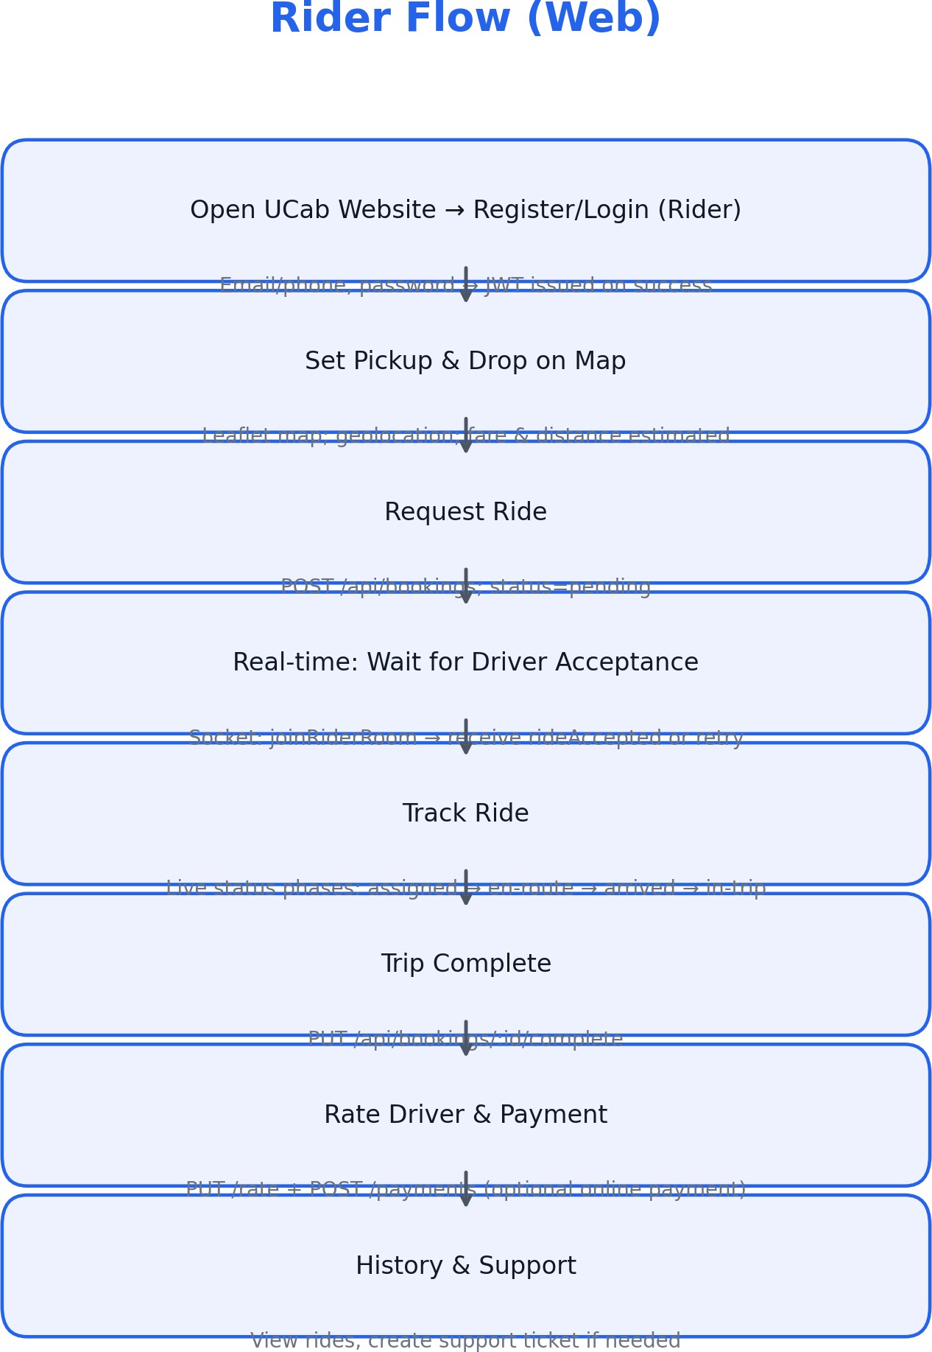

Figure 1: Rider flow on the website with key Socket.IO touchpoints.

Driver Flow (Website)

Login & Availability
  - Login as driver; toggle availability in dashboard.
  - Join vehicleType-specific Socket room (joinDriverRoom).

Receive & Accept Request
  - Listen for newRideRequest; view pickup, distance, fare.
  - Accept first; backend notifies rider and cancels others.

Navigate & Pickup
  - Update ride status as progressing to pickup (assigned → en-route → arrived).
  - Provide ETA updates to rider UI.

In- Trip & Complete
  - Start trip (in-trip) and mark completed at drop location.
  - Trip appears in driver history; rating averages update.

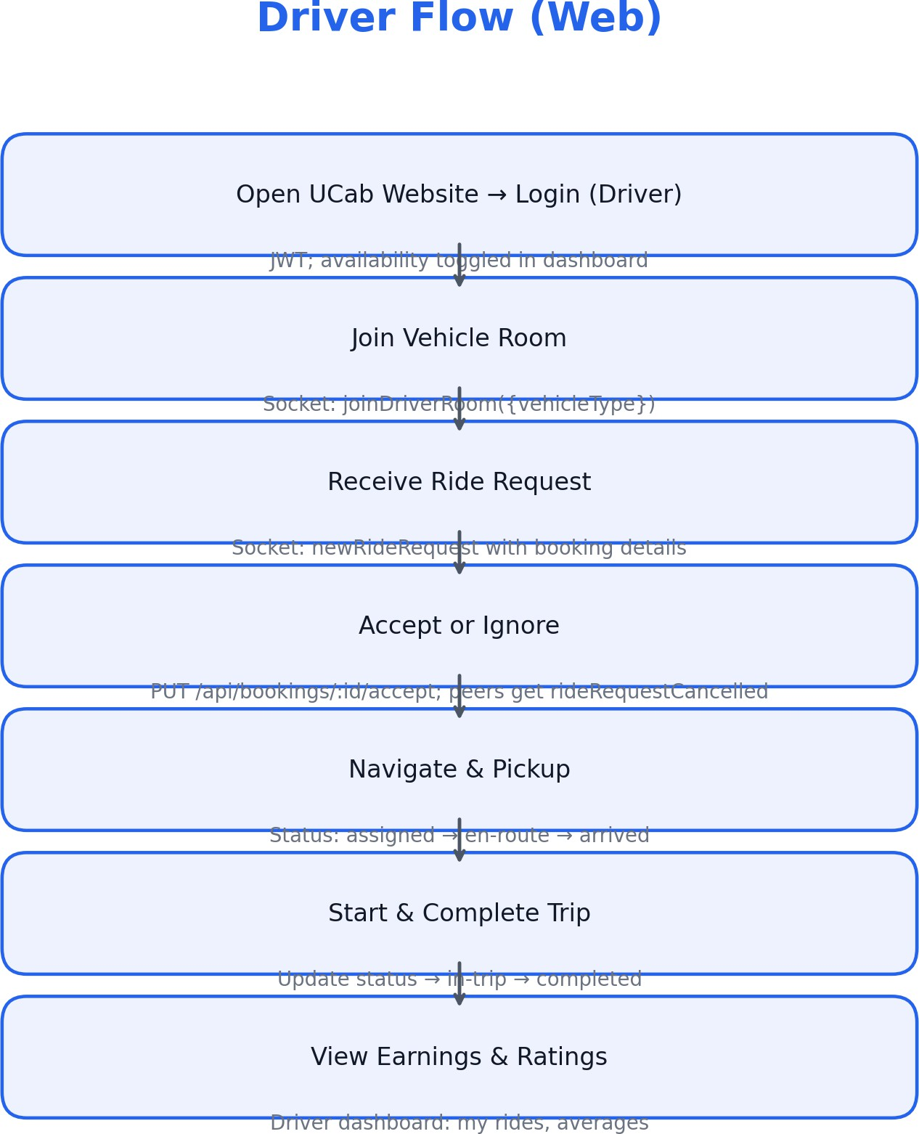

Figure 2: Driver flow on the website with acceptance and completion states.

Error States & Recovery
  - Authentication failures → friendly error, retry, and forgot-password link.
  - No drivers available → offer retry, change vehicle type, or schedule later.
  - Socket disconnects → exponential backoff and visual offline banner.
  - Backend failures → surface booking reference and support link.

Open Gaps Impacting Flows (from current implementation)
  - Frontend calls on non-existent APIs (e.g., /api/bookings/search, /api/drivers/register,
/api/drivers/:id/verify) should be removed or implemented to avoid dead-ends in UI.
  - Field naming mismatches (dropoffLocation vs dropLocation, estimatedFare vs fare) must be aligned to prevent submission errors and broken summaries.
  - Admin role implied by routes is not present in user schema; user flows referencing admin must remain hidden until role is formalized.
  - Payment status is written to booking, but schema lacks the field; add it or remove UI references to payment state.

Appendix: Key Real- time Events & Statuses

Socket.IO Events
  - Client → joinDriverRoom({ vehicleType })
  - Client → joinRiderRoom({ riderId })
  - Server → newRideRequest (to vehicleType room)
  - Server → rideAccepted (to rider room)
  - Server → rideRequestCancelled (notify competing drivers)

Booking Status Phases
  - pending → assigned → en-route → arrived → in-trip → completed

